**CSCE 5580: Computer Network**

**Homework-1**

**Name:** Kishan Kumar Zalavadia

**EUID:** 11685261

**1. (10 pts), Please list all the protocol layers in the Internet protocol stack and describe**

**their functionalities.**

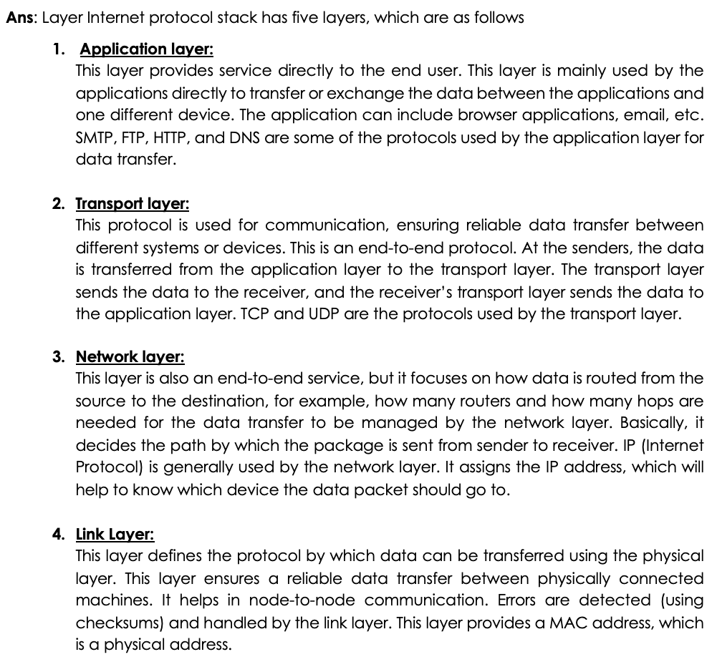

**2. (5+5 pts), Suppose within your Web browser you click on a link to obtain a Web page.**

**The IP address for the associated URL is not cached in your local host, so a DNS**

**lookup is necessary to obtain the IP address. Suppose that *n* DNS servers are visited**

**before your host receives the IP address from DNS; the successive visits incur an RTT**

**of RTT1, . . ., RTT*n*. Further, suppose that the Web page associated with the link**

**contains exactly eight very small objects on the same server. Let RTT0 denote the RTT**

**between the local host and the server containing the object. Assuming zero**

**transmission time of the object, neglecting transmission times, how much time elapses**

**with**

**a.** **Non-persistent HTTP connections?**

**b.** **Persistent HTTP?**

**3. (5+5 pts) Consider Figure3.5. What are the source and destination port values in the**

**segments flowing from the server back to the client’s processes? What are the IP**

**addresses in the network-layer datagrams carrying the transport-layer segments?**

**4. (10 pts) Suppose that the UDP receiver computes the Internet checksum for the**

**received UDP segment and finds that it matches the value carried in the checksum field.**

**Can the receiver be absolutely certain that no bit errors have occurred? Explain.**

**5. (15 pts) Consider our motivation for correcting protocol rdt2.1. Show that the receiver,**

**shown in Figure 3.57, when operating with the sender shown in Figure 3.11, can lead**

**the sender and receiver to enter into a deadlock state, where each is waiting for an**

**event that will never occur.**

**6. (20 pts) Consider a scenario in which Host A wants to simultaneously send packets**

**to Hosts B and C. A is connected to B and C via a broadcast channel—a packet sent by**

**A is carried by the channel to both B and C. Suppose that the broadcast channel**

**connecting A, B, and C can independently lose and corrupt packets (and so, for**

**example, a packet sent from A might be correctly received by B, but not by C). Design a**

**stop-and-wait-like error-control protocol for reliably transferring packets from A to B and**

**C, such that A will not get new data from the upper layer until it knows that both B and C**

**have correctly received the current packet. Give FSM descriptions of A and C. (Hint:**

**The FSM for B should be essentially the same as for C.) Also, give a description of the**

**packet format(s) used.**

**Packet format of Sender: [data | seq number]**

**Packet format of Receiver back to Sender: [ACK| seq number| from B or C]**

**Sender should follow have a timer to check timeout for sent package.**

**Ans**:

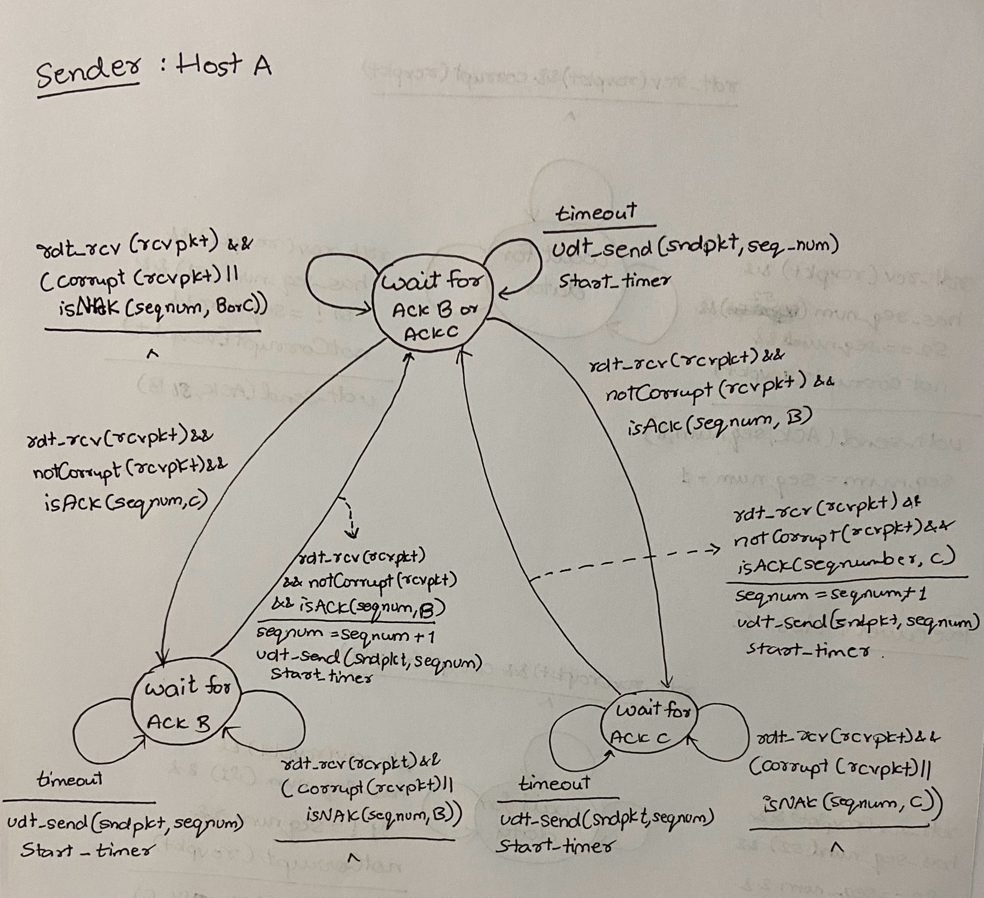

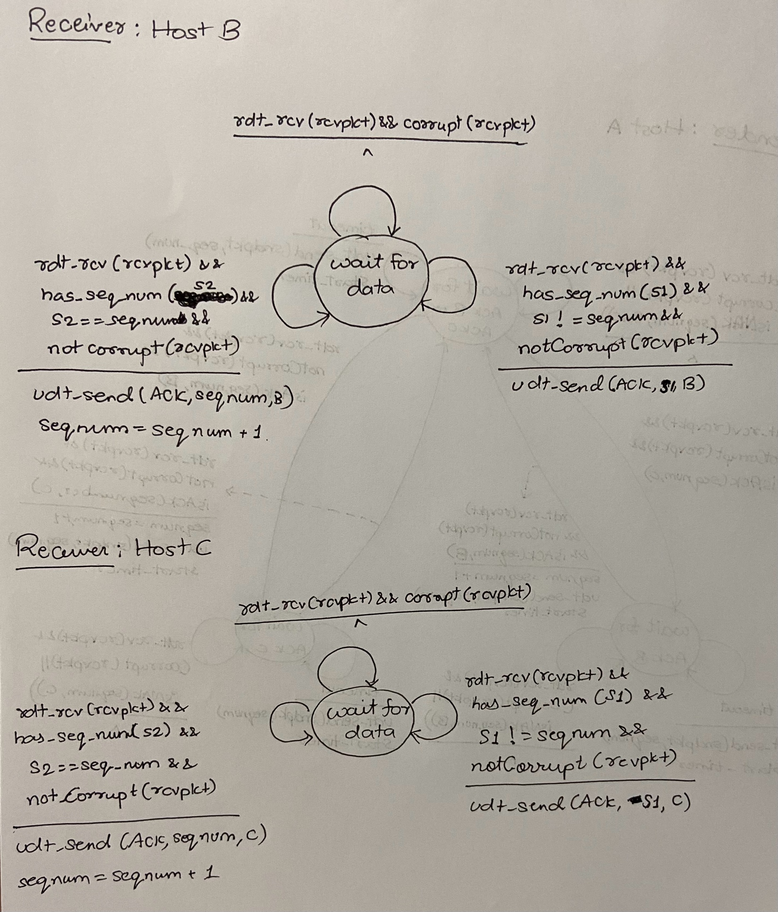

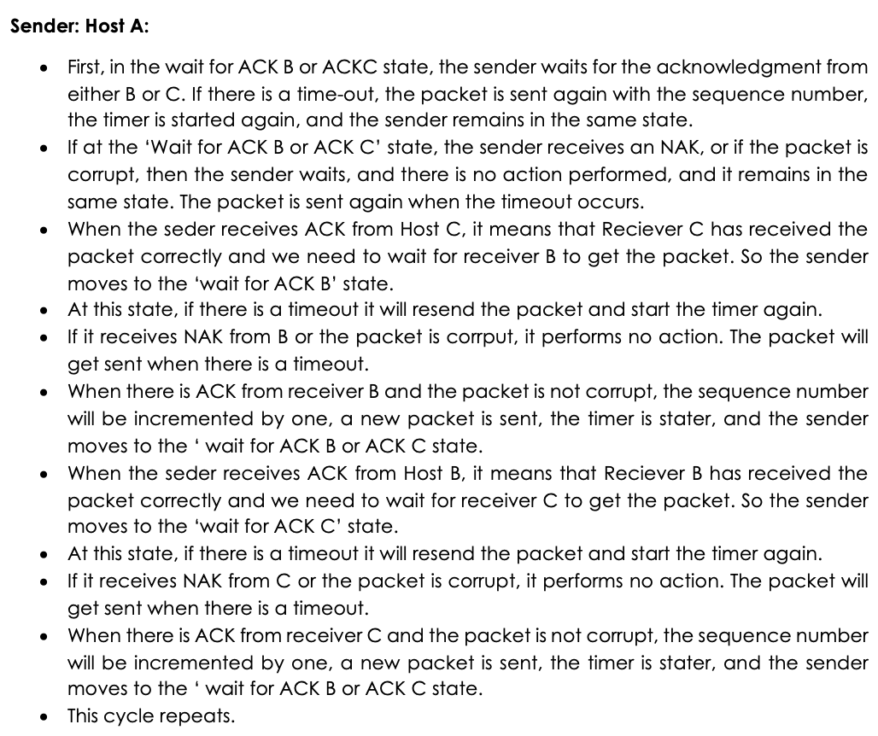

**7. (5+5+5+5 pts) Host A and B are communicating over a TCP connection, and Host B**

**has already received from A all bytes up through byte 126. Suppose Host A then sends**

**two segments to Host B back-to-back. The first and second segments contain 80 and**

**40 bytes of data, respectively. In the first segment, the sequence number is 127, the**

**source port number is 302, and the destination port number is 80. Host B sends an**

**acknowledgment whenever it receives a segment from Host A.**

1. **In the second segment sent from Host A to B, what are the sequence number, source port number, and destination port number?**

1. **If the first segment arrives before the second segment, in the acknowledgment of the first arriving segment, what is the acknowledgment number, the source port number, and the destination port number?**

1. **If the second segment arrives before the first segment, in the acknowledgment of the first arriving segment, what is the acknowledgment number?**

1. **Suppose the two segments sent by A arrive in order at B. The first acknowledgment is lost, and the second acknowledgment arrives after the first time-out interval. Draw a timing diagram, showing these segments and all other segments and acknowledgments sent. (Assume there is no additional packet loss.) For each segment in your figure, provide the sequence number and the number of bytes of data; for each acknowledgment that you add, provide the acknowledgment number.**

**Ans:**

When the acknowledgment is lost, the sender will again send the packet with sequence number 127 with 80 bytes because when the timeout occurs, the sender will think that the receiver has not received the packet.

**8****. (5 pts) True or False, give reasonable justification**

**1) Host A is sending Host B a large file over a TCP connection. Assume Host B has no data to send Host A. Host B will not send acknowledgments to Host A because Host B cannot piggyback the acknowledgments on data.**

**Ans**: False

